|  |
| --- |
|  |
| **Maine SIM Quarterly Status Report – FFY14 Q3** |
| **Maine State Innovation Model Quarterly Report to Center for Medicare and Medicaid Innovation** |
|  |
| **Randal J Chenard** |
| **7/31/2014** |

**1 Overview**

**Overview of Quarter’s Project Activities**

The Maine SIM Project remains generally on track with the milestones and therefore the Accountability Targets that are outlined in the Maine SIM Project Plan. This quarter, the Maine SIM Program has developed quarterly accountability targets for the first time, breaking down the accountability targets that were previously only stated as annual targets. The results show that nearly 82% of our quarterly targets are on track, and 18% of targets are behind schedule. Importantly, the 18% that are behind schedule are not weighted highly in terms of the importance of those targets in obtaining overall SIM outcome objectives. See figure 1.

Figure

The Maine SIM Project Plan has six major strategic objectives and currently has 20 major SIM objectives aligned under the strategic objective which it supports. The six overall SIM strategic objectives, or pillars, are as follows:

1. Strengthening Primary Care
2. Integration of Physical and Behavioral Health
3. Developing New Workforce Models
4. Developing New Payment models
5. Centralizing Data and Analysis
6. Engaging People and Communities

An executive level summary is now contained in this report that will provide a status summary organized by each SIM strategic pillar. The view enables reviewers to get a sense of how the high level SIM strategies are progressing, ie the ‘forest view’.

More detailed status for all SIM objectives are also provided through reports that are provided by each of the Maine SIM partners, ie, the trees view. Those partners are listed as follows:

* SIM Program Objectives, driven out of the Department of Health and Human Services
* Maine Health Management Coalition objectives
* Maine Quality Counts objectives
* HealthInfoNet objectives
* MaineCare objectives
* Maine CDC objectives

All of the objectives are assigned a status for Q3 based on quantifiable progress against the Accountability Targets, and an ‘outlook’ status, projecting the level of confidence that milestones and applicable accountability targets will be obtained during the fourth quarter of fiscal year ’14, with associated narrative supporting that outlook status. Further, all objectives are outlined in detail in the Maine SIM Project Plan, which clearly articulates objectives, milestones, and accountability targets which is attached with this report. Finally, a summary of accountability target achievement, as well as additional results regarding meetings held, reports distributed, stakeholder attendance, etc can be found in figures 3 and 4 below, respectively.

*Status Rating Key:*

* Green: Accountability targets were achieved at least at a 90% level.
* Yellow: Accountability targets were partially achieved. The final result was between 75 and 89% of the target goal.
* Red: Accountability Target results were <75% of goal.

Outlook Rating Key:

* Green: All’s well. At least a 75% level of confidence that milestones will be reached for that associated objective
* Yellow: Reason for caution exists. There is between a 50% - 75% level of confidence that all associated milestones will be achieved.
* Red: Concern is present, and confidence is, at most, at a 50% level that associated milestones will be achieved.

**Maine SIM Strategic Objectives Summary**

Figure 2 is a summary of the status of each SIM objective, with each objective aligned to the SIM strategic pillar which it supports. Each objective is aligned to at least one pillar, and many objectives are aligned to several strategic pillars. Each box aligned to each objective represents one quarter of the SIM timeframe from October of 2013 – Sept of 2016. The last quarter status for each objective is the status outlook for the next quarter, while earlier quarters represent actual achievement against SIM accountability targets. Details on SIM accountability target achievement and additional SIM quantifiable metrics can be found in figures 3 and 4 respectively.



Figure



Figure 3



Figure 4

*The SIM Strategic Pillar status summaries are below:*

**Strengthen Primary Care**

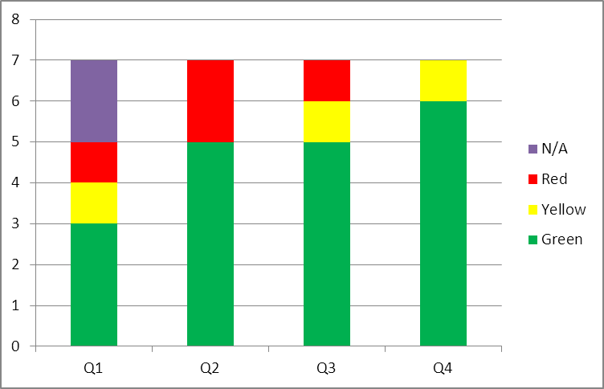

FFY 2014

The Strengthen Primary Care strategy has 5 objectives in green status, and 1 objective in yellow status, and one objective in red status. The objective in red status is MaineCare’s Accountable Community implementation, although the outlook for 4Q moves this objective to yellow as AC implementation is moving forward with an August 1 plan for implementation. MaineCare’s Primary Care Developmental Disability initiative achieved a yellow status for the 3rd quarter, but the outlook for this objective is positive for next quarter and moves to green. Details for the Accountable Community implementation objective is outlined in the MaineCare status report, included in section 2. This risk has been aggressively managed throughout the 3rd quarter and significant progress has been made.

**Integrate Physical and Behavioral Health**

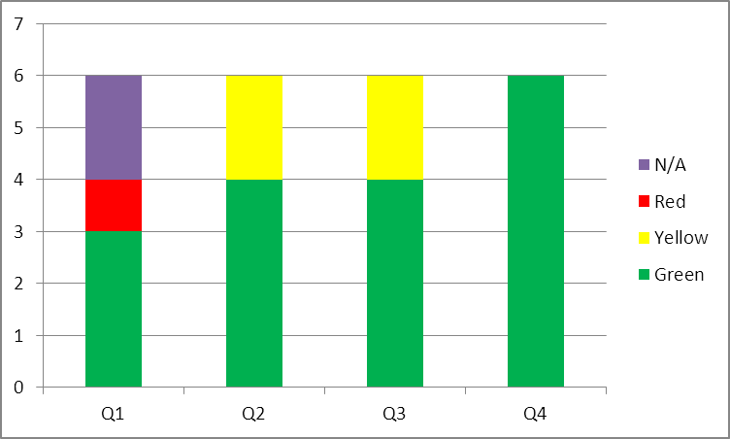

FFY 2014

The Strategic objective of the integration of physical and behavioral health remains steady, with a positive outlook. The two objectives that are in ‘yellow’ status are as follows:

MaineCare Objective #2: Implementation and ongoing support of Behavioral Health Homes and

Maine Quality Counts Objective #3: Quality Improvement support for the BHH Learning Collaborative.

While these above objectives are in ‘cautious’ status, both have recently accomplished major milestones with the formal launch of Behavioral Health Homes on April 1, and the BHH QI support kick-off meeting that was held on April 29. While both objective fell slightly short of accountability target in the FFY3Q, optimism ensues and the outlook for both for the 4th quarter is green, expecting both objectives to get back on track fully. More detailed information can be found in the MaineCare and MaineQuality Counts quarterly reports, included in section 2.

**Develop New Workforce Models**

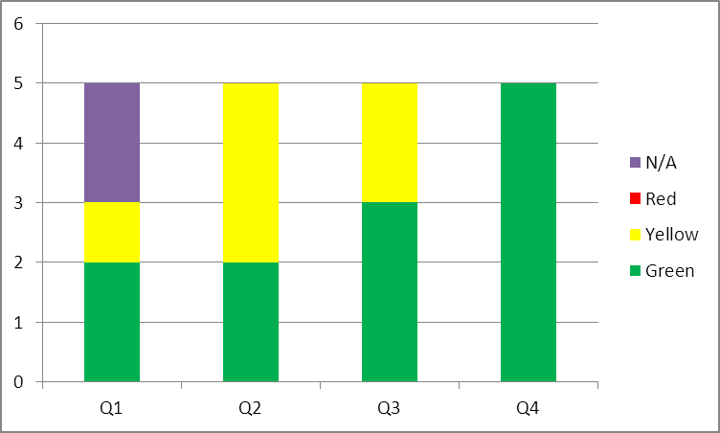

FFY 2014

Two objectives are in yellow status under the Strategy to Develop New Workforce models, as follows:

Quality Counts, Objective 3: QI Support for BHHs. This objective also supports the Integration of Physical and Behavioral Health, and the status here is the same as provided regarding that strategy.

MaineCare, Objective 3: Develop and Implement Physical Health Integration workforce Development to Mental Health Rehab Curriculum. This objective started later than anticipated which is the reason for the yellow status, however, solid progress is being made in the identification of a vendor for this work, and the procurement direction should be finalized through SIM governance early in the FFY4Q. Assuming that occurs, all objectives for this strategy should be in green status in the 4Q.

**Develop New Payment Models**

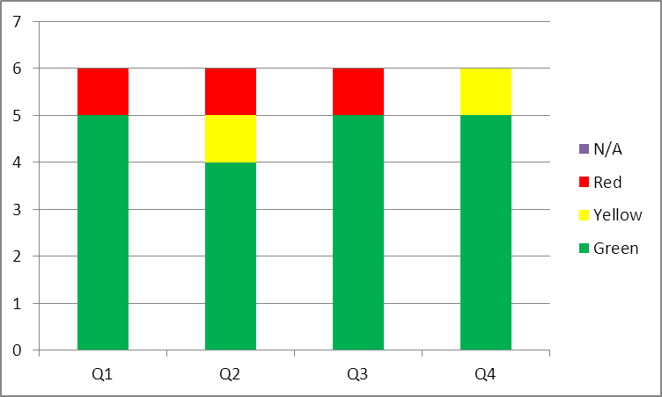

FFY 2014

One objective under the strategy to Develop New Payment Models is in red status, MaineCare Objective 1, Accountable Communities implementation and ongoing support. This objective is also aligned to the Strengthen Primary Care strategy, and the status was described previously in that section above. Again, important to note that the status outlook for that objective is expected to move to yellow for the 4Q. A positive trend.

All other objectives aligned to this strategy are in green status. While accountability targets are generally being positively attained, some concern exists through SIM governance regarding the pace of payment reform, and a desire for acceleration of the development of these payment reform models. Several risks are outlined against that concern, and active discussions, overseen by the SIM program, are occurring. More definitive plans and actions in regards to those risks will emerge during the 4th q.

**Centralize Data and Analysis**

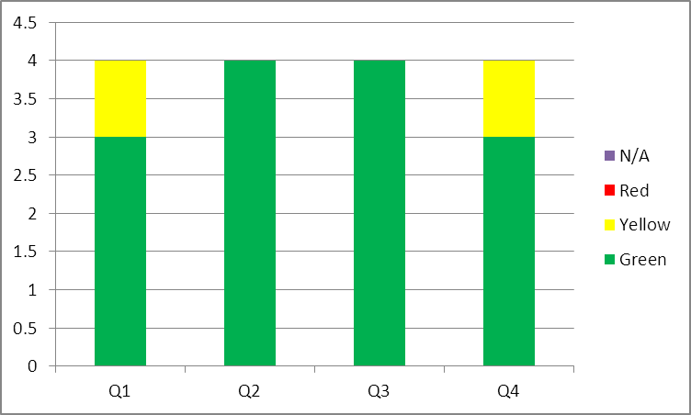

FFY 2014

Centralize Data and Analysis is comprised of 4 objectives, all which achieved green status for the 3rd quarter. For next quarter, the outlook for MHMC’s objective 3 moves to yellow. This will become a watch area, as delays with the availability of the APCD have occurred. Details of those concerns are outlined in MHMCs quarterly report in section 2.

**Engaging People and Communities**

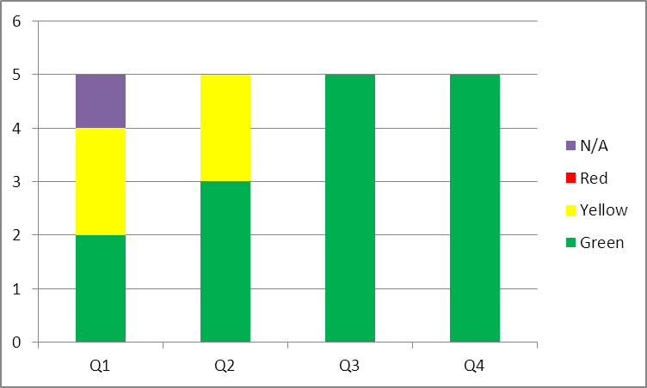

FFY 2014

The trend is very positive for the four objectives aligned under Engaging People and Communities, and the outlook is all positive.

**SIM Program**

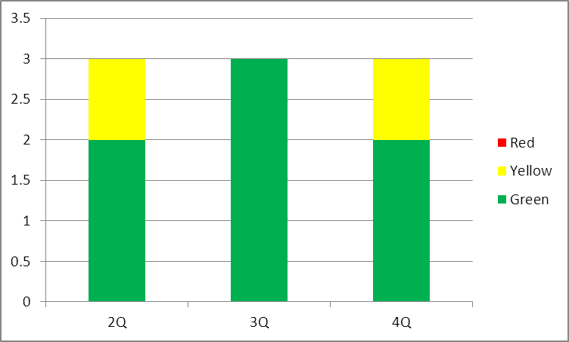

FFY 2014

SIM Program objectives are generally in good shape. One objective, regarding the SIM Operational Plan, has a yellow outlook for the 4th Quarter due to a potential gap in SIM resources. Hiring however did proceed as planned in the 3rd quarter, and additional project management resources were added to the SIM program team. In addition, a major barrier was overcome with the sourcing of the self-evaluation vendor for SIM, and contract finalization with the Lewin group is imminent. We expect significant progress in the 4th quarter with the layering in of evaluation measures upon the current SIM strategic framework.

Please find the full information of the SIM Program objective status and outlook in the attached report:



**Section 2: Detailed Quarterly Status Reports**

*Maine Health Management Coalition 3Q Objective Status and 4Q Outlook*



*HealthInfonet 3Q Objective Status and 4Q Outlook*

**

*Maine Quality Counts 3Q Objective Status and 4Q Outlook*



*MaineCare Objective 3Q Status and 4Q Outlook*



*Maine CDC 3Q Objective Status and 4Q Outlook*



*SIM Budget*

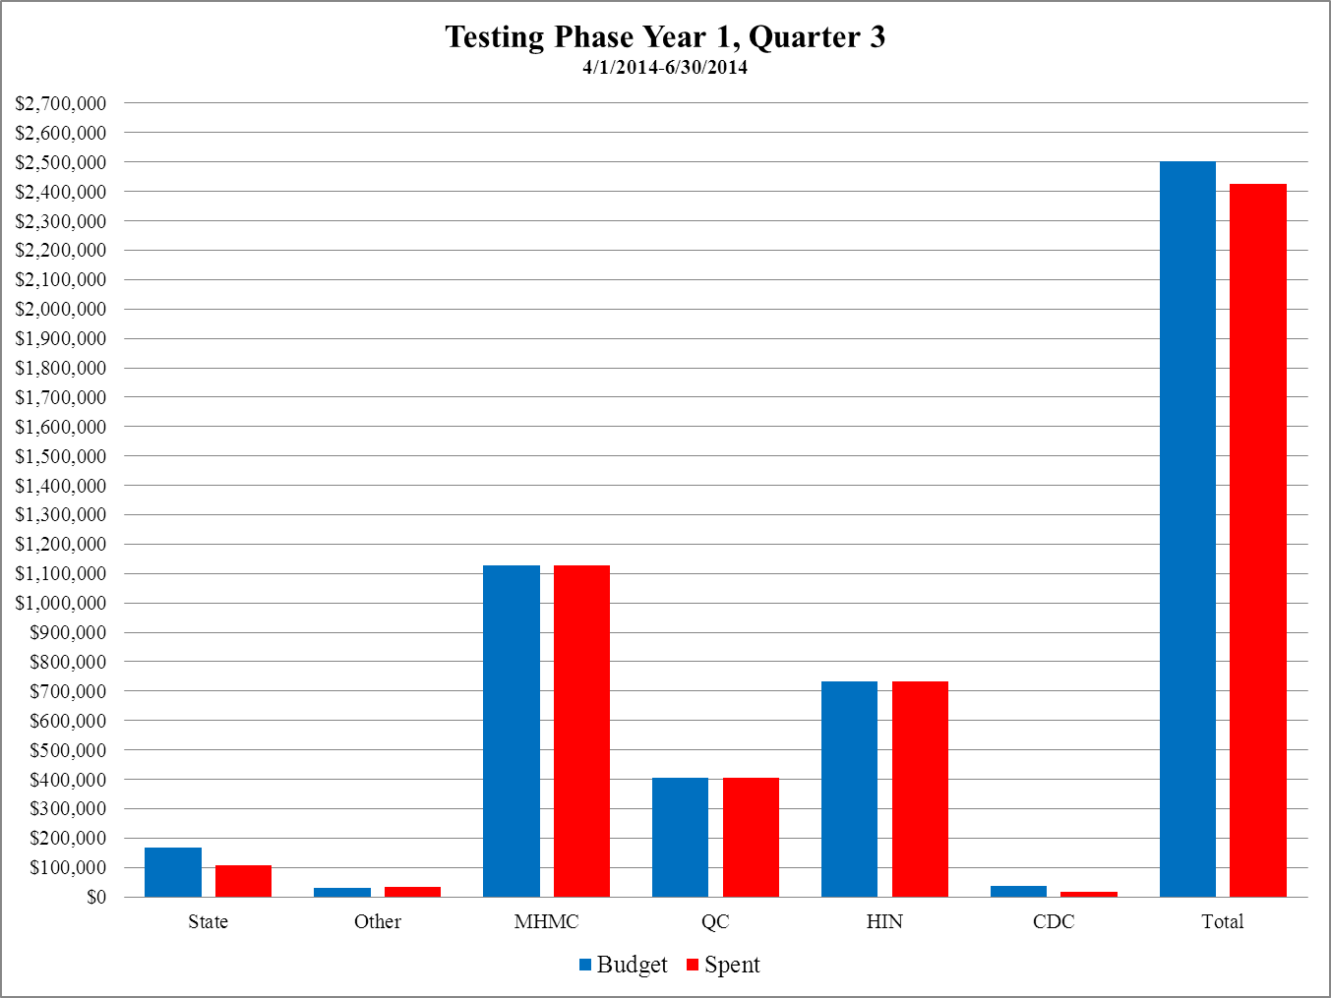

**Section 3 Accomplishments and Planned Activities Over the Next Quarter and Likelihood of Achievement**

All Status and Outlooks, provided in Section 1, are based on SIM Program Plan, attached below:



**4 Substantive Findings and Lessons Learned**

* High level architecture of strategic goals should be a requirement of the SIM operational plan
* Processes to manage integration and dependencies should be a requirement of SIM operations

**5 Findings From Self-Evaluation**

Self-Evaluation has not started yet

**6 Problems Encountered/Anticipated and Implemented or Planned Solutions**

Detail included in work stream detail included above. In addition, Risk/Issue Log is attached here that outlines Risks and Issues identified to date. A Risk/Issue mitigation plan was developed based upon the risks and issues that are prioritized as the highest risks to SIM success. A summary and details of the SIM risks, issues, and associated plans are included in the documents below



**7 Work Breakdown Structure**



**9 Point of Contact**

Randal J Chenard

SIM Program Director

221 State Street

Augusta, Maine 04333

207-287-5013